FUNCTIONAL SPECIFICATION DOCUMENT (FSD)
Metro Ticket Generating System in ServiceNow

Project Name | Metro Ticket Generating System in ServiceNow
Prepared By | AJEES M
Platform | ServiceNow
Date | 05 October 2026

1. Introduction
Project Title: Metro Ticket Generating System in ServiceNow
Project Owner / Contributor: Veda Sarathi V
This Functional Specification Document adapts the supplied full-stack documentation format to the actual ServiceNow implementation. Where the supplied template refers to React, Node.js, Express.js, MongoDB, npm commands or REST endpoints, the equivalent ServiceNow component is documented instead; unsupported technologies are not claimed.
2. Project Overview
Purpose
Digitize metro ticket booking through a centralized ServiceNow workflow that captures journey details, calculates fares, stores booking data, generates a digital QR ticket and supports operational verification.
Key Features
• Service Catalog-based ticket booking.
• Source, Destination, Passenger Type and Number of Tickets variables.
• Automated fare/station mapping logic.
• Flow Designer-based request processing.
• Request/RITM tracking.
• Custom Metro Database table for structured booking records.
• QR-based digital ticket presentation.
• Service Portal widget/spModal implementation.
• Roles and ACL-based access control.
• Flow Execution Details for troubleshooting.
3. Architecture
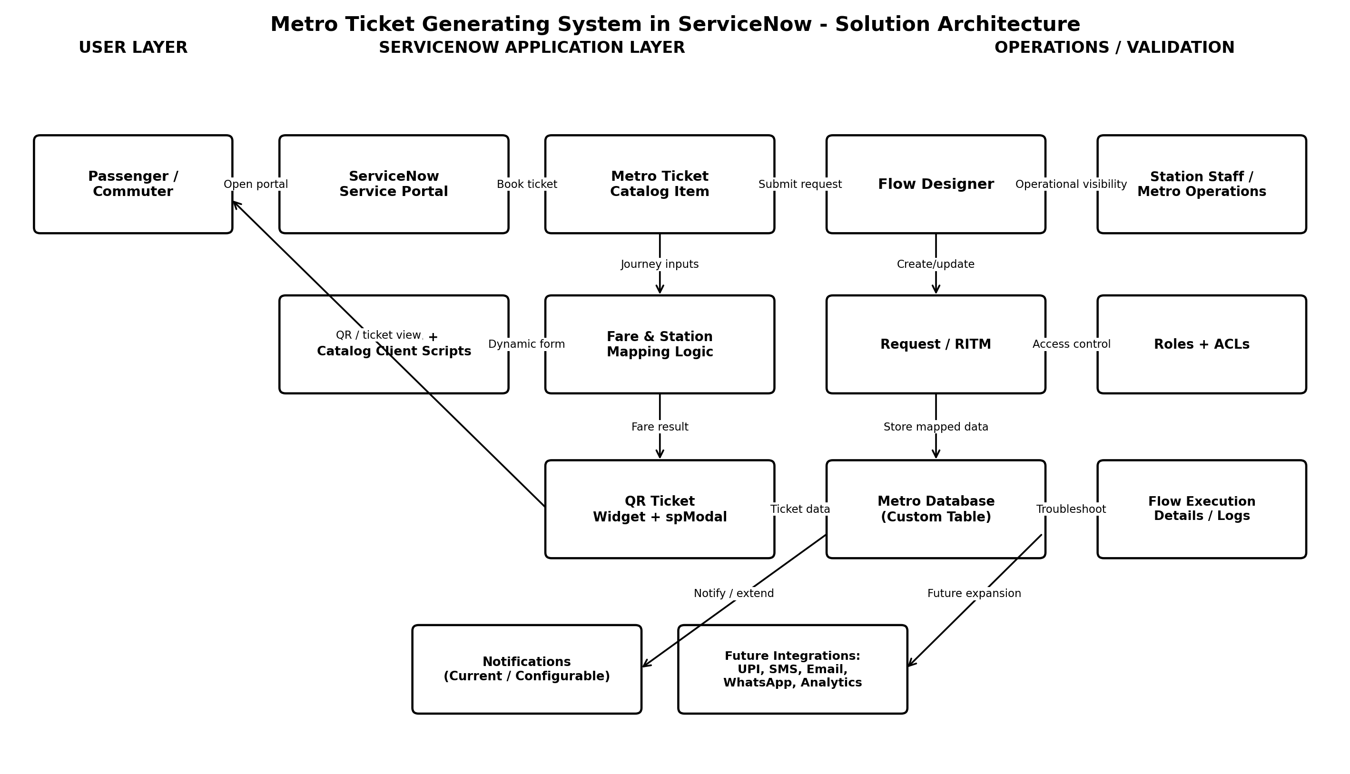
Figure 1. ServiceNow solution architecture
Frontend / User Interface
Equivalent to the frontend layer in the supplied format, the project uses ServiceNow Service Portal and Service Catalog. The passenger interacts with catalog variables, UI Policies and essential Catalog Client Scripts. QR ticket presentation is handled using a Service Portal-compatible widget and spModal.
Backend / Application Logic
The backend equivalent is ServiceNow platform logic. Flow Designer is the primary automation engine. Fare and station mapping logic processes journey inputs, while Request/RITM records maintain the request lifecycle.
Database
ServiceNow records are used instead of MongoDB. The custom Metro Database table stores structured booking/ticket fields, while Request and Requested Item records preserve the service-request context.
4. Setup Instructions
Prerequisites
• Access to a ServiceNow Personal Developer Instance (PDI) or authorized ServiceNow instance.
• Permission to configure Service Catalog, Flow Designer, tables, roles and ACLs.
• Service Portal/widget configuration access where required.
• Test users/roles for requester and operational validation.
Configuration Sequence
1. Create the Metro Ticket Service Catalog item.
2. Create and configure booking variables: Source, Destination, Passenger Type, Number of Tickets, and related fields.
3. Configure station/fare mapping logic.
4. Create the custom Metro Database table and required fields.
5. Build the Flow Designer workflow and variable-to-field mappings.
6. Configure Request/RITM processing and required notifications/tasks.
7. Configure UI Policies and only the essential Catalog Client Scripts.
8. Create/configure the QR ticket widget and spModal presentation flow.
9. Configure roles and ACLs.
10. Run portal, workflow, mapping, QR, security and UAT tests.
5. Configuration / Component Structure
The supplied template contains a source-code folder structure for MERN. This ServiceNow project is configuration-driven, so the equivalent structure is shown below.
Configuration Area | Contents
Service Catalog | Metro ticket catalog item and catalog variables.
Client Configuration | UI Policies and required Catalog Client Scripts.
Automation | Flow Designer flow, actions, conditions and task creation.
Data Model | Request/RITM and custom Metro Database table.
Portal Components | Service Portal page/widget and spModal QR ticket display.
Security | Roles and ACL records.
Operations / Diagnostics | Flow Designer Execution Details, logs and testing records.

6. Running the Application
There are no npm or local server commands because the application runs inside ServiceNow. To use the solution, open the configured ServiceNow Service Portal, navigate to the metro booking catalog item, enter the journey information, submit the request, and follow the generated request/ticket flow.
• Requester path: Service Portal -> Metro Ticket Catalog Item -> enter details -> submit -> track request -> open QR ticket.
• Administrator path: ServiceNow backend -> Flow Designer / tables / security configuration -> monitor executions and records.
• Station/operations path: authorized ticket/record view -> verify booking/QR information.
7. API Documentation
No external REST API endpoint was documented as part of the current implemented scope. The solution primarily uses native ServiceNow platform components and record interactions. Future integrations may expose or consume APIs for payment gateways, SMS, email, WhatsApp services or metro operational systems.
Integration | Current Status | Purpose | Future Interface
Payment Gateway / UPI | Future | Collect digital payment during booking. | External payment API
SMS | Future | Deliver ticket/confirmation. | SMS provider API
Email | Future / configurable notification | Send booking/ticket information. | ServiceNow notification/email service
WhatsApp | Future | Alternative booking/ticket channel. | WhatsApp Business API

8. Authentication & Authorization
Authentication is provided by the ServiceNow instance. Authorization is implemented through roles and Access Control Lists (ACLs). The requester accesses their booking/request experience, while authorized station/operations/admin users access operational records according to configured permissions.
• Passenger/requester: submit ticket request and view permitted request/ticket information.
• Station/operations user: access ticket records required for operational verification.
• Administrator: configure catalog, flow, data model, portal components, roles and ACLs.
• ACL rules: restrict read/write/create/delete access based on user role and record context.
9. User Interface
The primary user interface is the ServiceNow Service Portal catalog experience. The form captures journey data, applies dynamic field behaviour, submits the request and provides ticket/request visibility.

Figure 2. Project workspace / documentation context
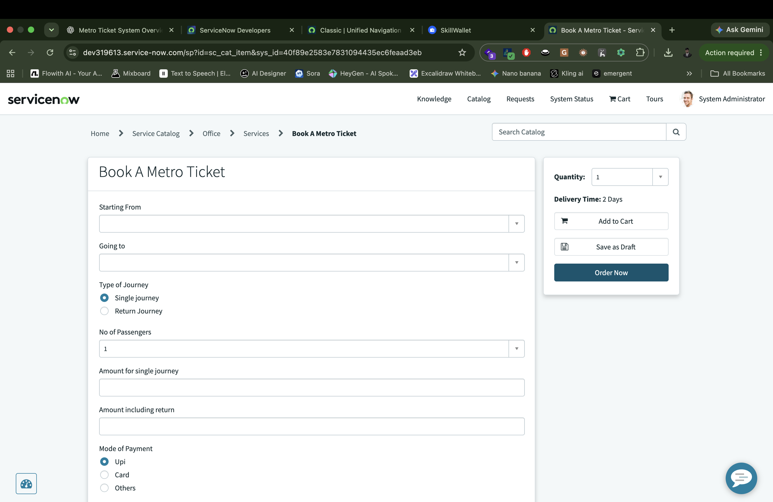
Additional implementation screenshots can be inserted for the catalog form, Flow Designer, custom table, QR ticket view, ACL configuration and execution logs when available.
10. Testing
Test Area | Coverage | Status
Catalog form | Source/destination, passenger type, ticket quantity and required fields | Pass
Fare logic | Representative routes and quantities | Pass after mismatch correction
Flow Designer | Request trigger, conditions, record creation and execution path | Pass
Data mapping | Catalog variables to Metro Database fields | Pass after mapping correction
QR ticket | Portal rendering and verification | Pass after widget/spModal fix
Security | Roles and ACLs | Pass
UAT | End-to-end passenger journey | Pass

11. Screenshots or Demo
A final demonstration should show: Service Portal -> Book A Metro Service -> enter journey details -> submit request -> track request -> view stored Metro Database record -> open QR ticket -> validate ticket from the authorized operational perspective.
Project demo link: Not supplied in the documentation set. Insert the final demo video/deployed link before submission if required.
12. Known Issues
Issue / Limitation | Status | Resolution / Note
QR rendering / Service Portal sandbox | Resolved | Implemented widget + spModal architecture.
Fare mismatch | Resolved | Refined fare/station mapping and retested.
Variable-to-field mapping | Resolved | Corrected bindings and population logic.
Flow execution path failures | Resolved | Used Flow Execution Details for diagnosis.
Payment gateway | Not implemented | Future scope.
SMS/WhatsApp ticketing | Not implemented | Future scope.
Production load benchmark | Not measured | No exact production-scale performance benchmark was supplied.

13. Future Enhancements
• Integrated UPI/card/wallet payment.
• Email, SMS and WhatsApp ticket delivery.
• Travel analytics and route-demand dashboards.
• Monthly/season passes, cancellations and refunds.
• Real-time station and service information.
• Offline-friendly ticket access.
• Integration with production metro AFC/validation systems.
• Expanded mobile experience and accessibility improvements.
Appendix - Functional Data Mapping
Data Element | Source | Destination | Purpose
Source Station | Catalog variable | Metro Database source field | Used by fare/station logic.
Destination Station | Catalog variable | Metro Database destination field | Used by fare/station logic.
Passenger Type | Catalog variable | Passenger-type field | Used for booking classification/fare rules where applicable.
Number of Tickets | Catalog variable | Ticket quantity field | Used in total fare processing.
Fare | Calculated/processed value | Fare field | Stored for ticket and validation.
Request Reference | REQ/RITM | Request reference field | Supports status tracking.
QR/Ticket Data | Generated ticket data | Ticket/QR field or rendered context | Displayed in portal widget/spModal.

